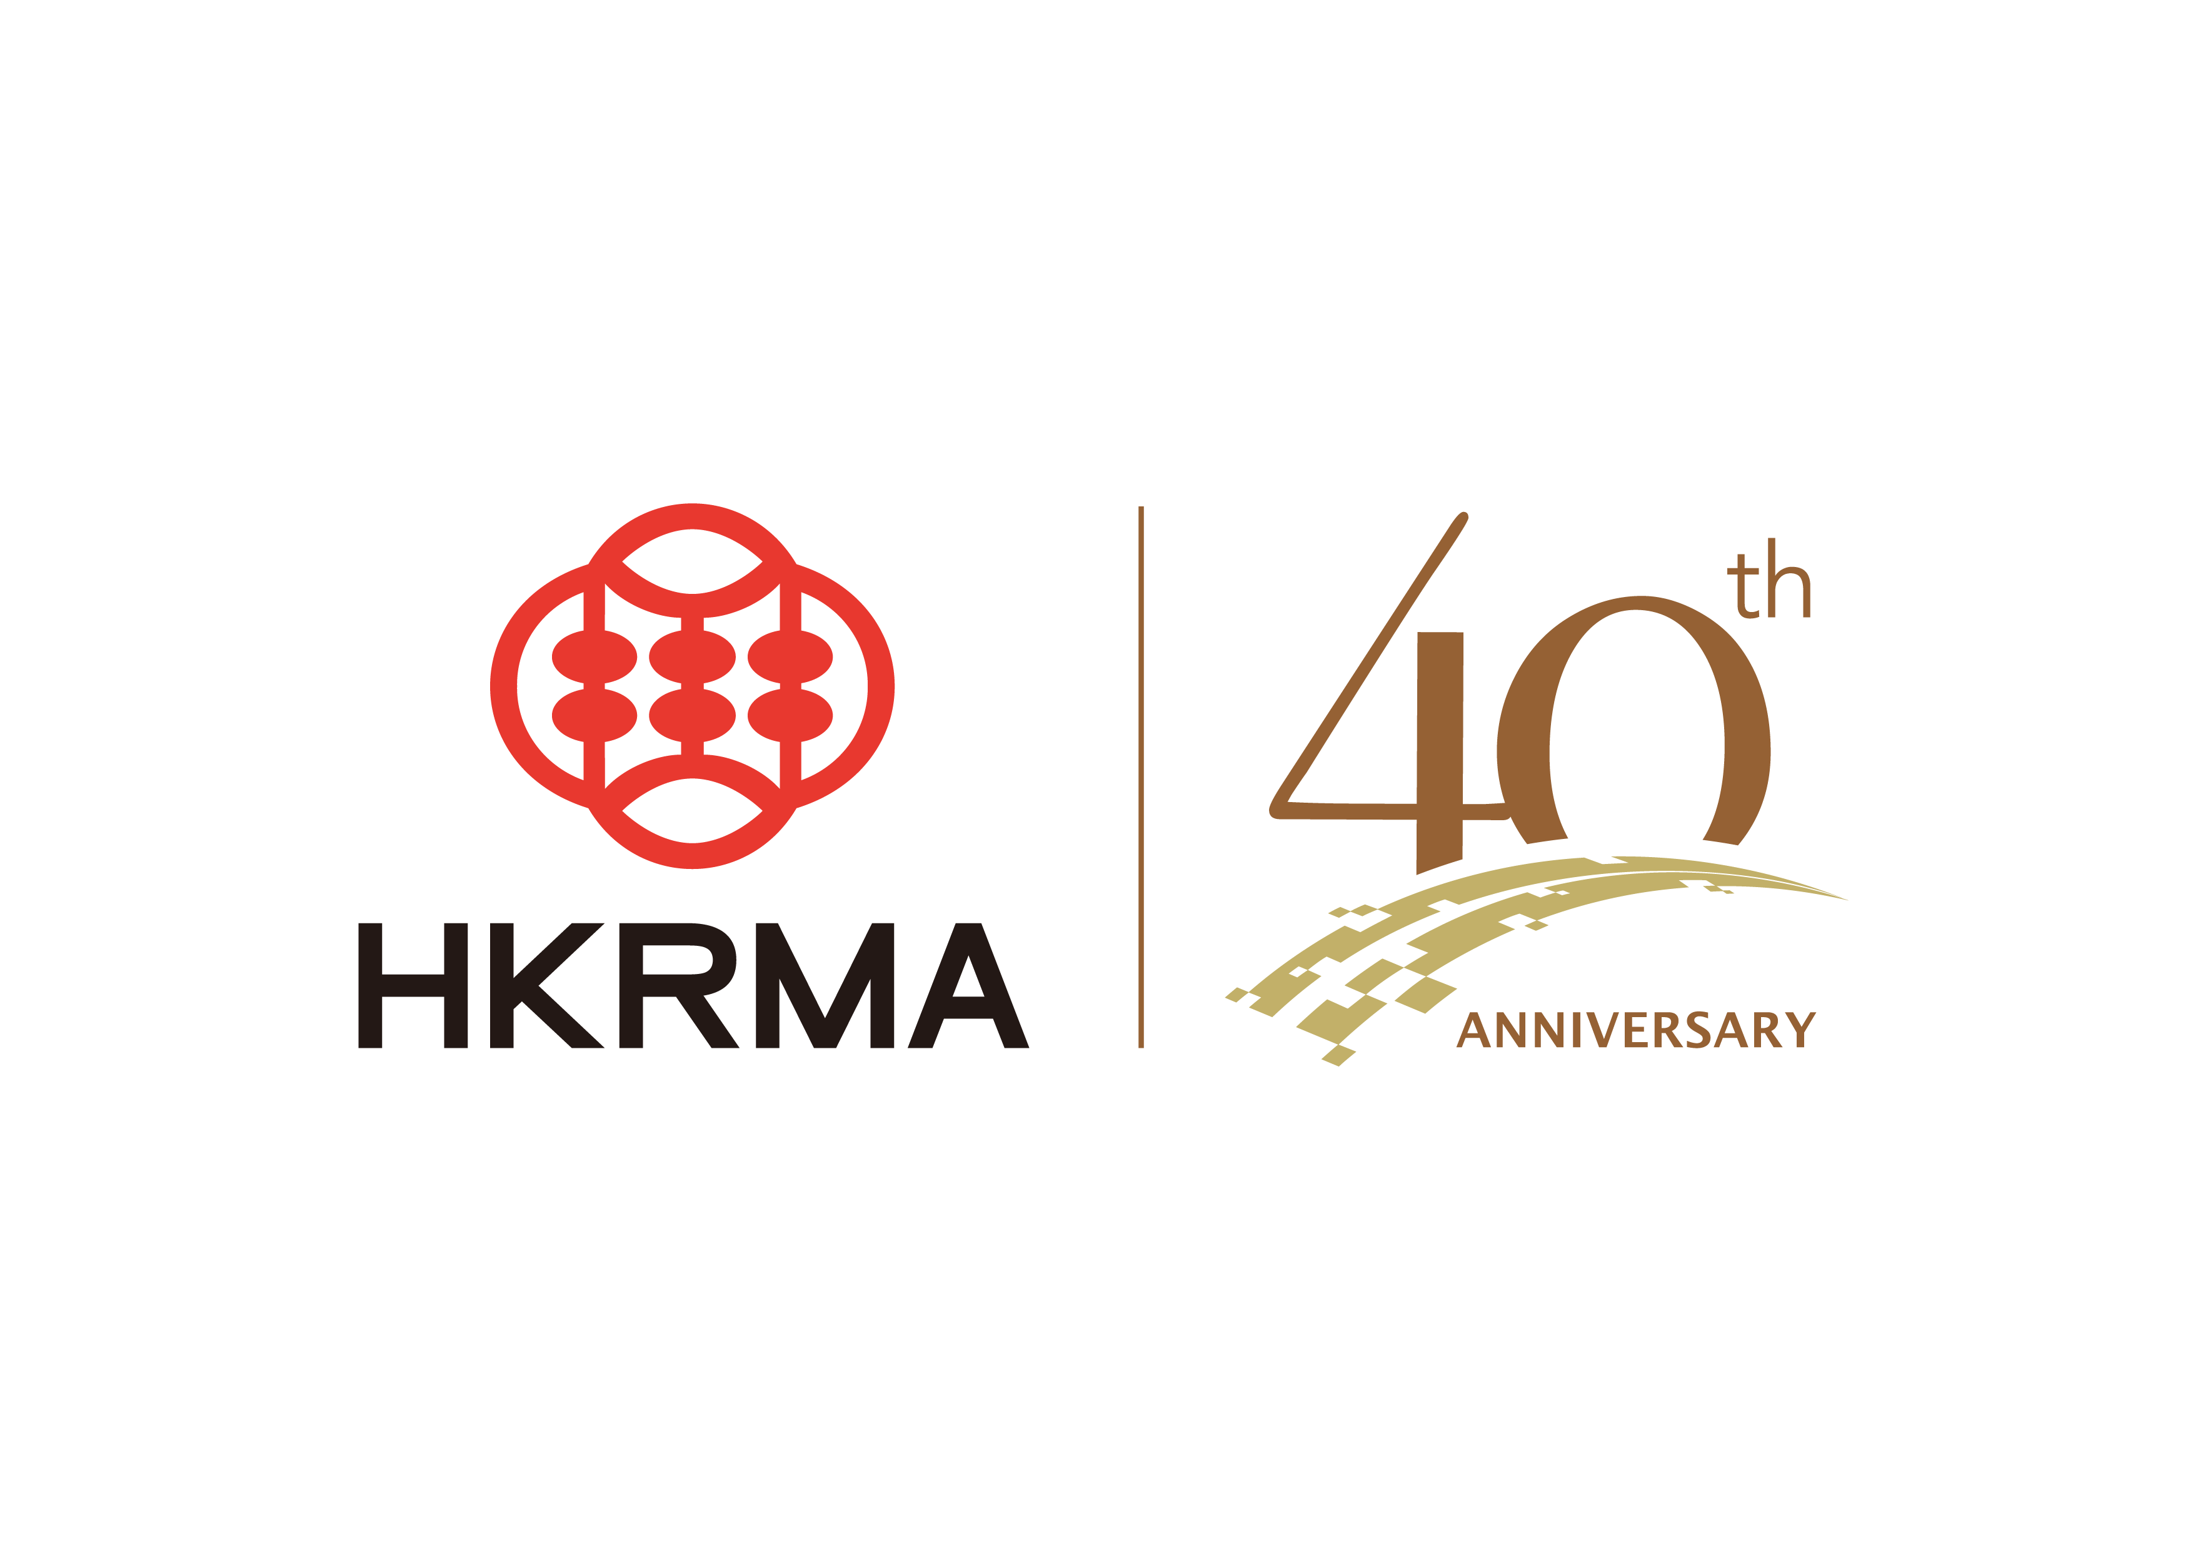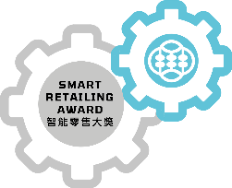
2025 Smart Retailing Award 智能零售大獎
Smart Transformation & Innovation Award
智能轉型及創新獎
Proposal計劃書
(Applicable to Retailers適用於零售商)

Please email this proposal in WORD Format and presentation PowerPoint to eo@hkrma.org on or before 25 July 2025.

Please complete the following parts ALL in ENGLISH or ALL in Chinese and put ✓where appropriate.
請以全英文 或全中文完成以下各部份及在適當位置填上✓。
Company Information 公司資料
Company Name  公司名稱 | (English)
 | (中文)
Please briefly describe the nature of business and customer group of your company in ENGLISH (no more than 200 words):
請簡述公司業務和客戶性質（不多於200字）：

Project Information 參賽項目資料
Please provide basic information of the project / the campaign. 請提供參賽項目 / 活動計劃的基本資料。
English Name英文名稱
(For promotional use
作宣傳之用)
Chinese Name中文名稱
(For promotional use
作宣傳之用)
Area範疇 |  | Please select the area of your participating project involved, your choice can more than one. 請選擇參賽項目所屬的零售業務範疇, 可以選多於一項。
 |  |  | Customer Attraction 吸引顧客
 |  |  | Customer Experience 顧客體驗
 |  |  | Order Fulfillment 交易履行
 |  |  | Retail Operations ( 零售業務營運
 |  |  | Cross border Retailing 跨境零售
 |  |  | Eco-Friendly Retailing 推崇綠色零售
Eco-Friendly Retailing  推崇綠色零售 |  |  | Responsible consumption-driven solution for environmental sustainability  促進綠色經濟，確保永續消費行為對環境可持續性
Responsible production-driven solution for carbon reduction
促進減碳排放生產模式方案
Deployed environmental-friendly marketing campaign for public education.
進行環境友善市場推廣活動以推動環保教育
Adopted green concept designed store / business operation model
採用環保概念設計門店 / 營運模式
If your participating solutions covered the aspects of eco-friendly retailing, then you are entitled to compete for the“Smart Green Retail Brand Award”
如貴公司參賽方案涵蓋環保友善零售元素，即合資格競逐「綠色智能零售品牌獎」。

Objective (No more than 200 words) 目標 (不多於200字)
Please specify the objectives of your project.
請說明參賽項目的目標。
Overall Strategy (No more than 100 words) 總體策略(不多於100字)
 | Please elaborate the ways to implement the project according to the S.M.A.R.T criteria. Please indicate the target beneficial segments. 請根據S.M.A.R.T準則詳細說明項目的實施方式，並指示受惠目標群。
for internal: improving operational efficiency in frontline / backend.
內向優化營運效率, 包括前線 / 後勤
for external: enhancing customer experience, engagement, loyalty.
外向提升顧客體驗、參與度及忠誠度
for both: please list the percentage _________% for internal and _________% for external.
內向及外向兼備, 並列出優化內向的比例 _________%及優化外向的比例 _________%
S | Specific具體  Please state the rationale for the project on how to 1) overcome business pain points and; 2) transform company business or culture.  請說明參賽項目如何 1) 解決/改善零售業務痛點及 2)轉化公司業務或文化。
M | Measurable可衡量  Please specify how to quantify (1) the performance in its reliability and stability; (2) effectiveness of the project after the implementation; and (3) the results obtained from the assessment.  請具體說明如何量化 (1) 其可靠性及穩定性方面的表現；(2) 參賽項目在實施後有效性；及(3)其評估後的成效。  Performance in its reliability and stability可靠性及穩定性方面的表現  Effectiveness of the project after the implementation項目在實施後有效性  Results of assessment (if applicable esp. for the solution covered the area of eco-friendly retailing)  評估成效 (如適用, 尤其參賽項目涵蓋 “推崇綠色零售” 元素)
Attainable可達成
Please elaborate how the project impacts the following areas.
請詳細說明參賽項目對以下範疇的影響。
Retail industry零售業

Customer experience顧客體驗

Company Culture 公司文化
Employee experience (if it is easy to set up, learn and use)僱員體驗(是否容易設置、學習及使用)

R | Radical革命性  Please specify the most distinctive, innovation and creative areas of your project.  請具體指出參賽項目中最具特色、創新和創意的範疇。
T | Timely適時  Please specify how the project is realistic with flexible timeline in implementation and enhancement.  請具體說明參賽項目在實施和改進兩方面的時間表上的現實性及靈活性。
Other reference information 其他參考資料
Please list the Award or recognition related to the project received in the recent 2 years (if applicable).
請列出參賽項目於最近兩年獲得的獎項或認可 (如適用)。
Awarded Year  獲得年份 | Award or recognition  獎項或認可 | Organization  主辦機構

Please put ✓and provide related reference of your project (if applicable).
請填上✓並提供參賽項目的相關參考資料（如適用）。
 | Brochure小冊子 | Please provide e-version if have.  如有，請附上電子版本。
 | Media interview媒體採訪
 | Related photos相關相片
 | Website網站 | http://
 | Other, please state 其他，請說明

Information of Contact Person 聯絡人資料
Name 姓名 | (Mr./Ms./Mrs./Dr) | Title 職位
Tel 電話 |  | Email 電郵

Declaration聲明
I declare that I have been authorized by the company of the present application and submission to make the following declaration:
本人謹此聲明，本人已獲本申請的公司授權作出以下聲明：

The submitted solution & application is developed and copyrighted by Hong Kong registered companies and can be distributed and licensed to retailers for use.
參與公司所提交的解決方案及應用是由香港註冊公司開發及擁有其版權，並可提供及給零售商使用。
The information stated in this proposal are real and authorized.

此計劃書所提供的的資料均為真實及已授權。
We agree to share our video record in the Open Presentation to the industry as best practice sharing.
本公司同意向業界分享公開演說的錄影內容作最佳作業分享。

Remark:

Please send (1) Proposal in WORD FORMAT and (2) Presentation PowerPoint to eo@hkrma.org on or before 25 July 2025.

請於2025年7月25日或之前電郵 (1)計劃書的WORD檔及 (2)演說POWERPOINT至 eo@hkrma.org。

